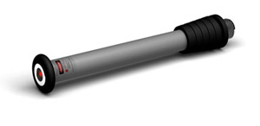
What is Laser Therapy?
Laser therapies are medical treatments that use focused light. Unlike most light sources, light from a laser (which stands for light amplification by stimulated emission of radiation) is tuned to specific wavelengths.

How Does it Work?
Low-level laser (light) therapy is a fast-growing technology used to treat a multitude of conditions that require stimulation of healing, relief of pain and inflammation, and restoration of function. Although the skin is the organ that is naturally exposed to light more than any other organ, it still responds well to red and near-infrared wavelengths. The photons are absorbed by mitochondrial chromophores in skin cells. Consequently electron transport, adenosine triphosphate (ATP) nitric oxide release, blood flow, reactive oxygen species increase and diverse signaling pathways get activated. Stem cells can be activated allowing increased tissue repair and healing.

What is Laser Therapy Used For?
- lowering inflammation
- Wound healing/Tissue growth and repair
- Depression & Anxiety
- Pain relief
- Arthritis
- Back pain & neck pain
- Autoimmune conditions
- Traumatic brain injuries
- Tooth & gum tissue repair
- Stimulate Hair growth
- Acne & scars
- Skin conditions
- Heart attack – hastens healing of the damage
- Fractures
- Fibromyalgia
- Improving bone density
- Neuropathy
- Muscle tissue for performance, fatigue and repair
- Spinal cord injury
- Injuries in connective tissue/joints
- Carpal Tunnel Syndrome
- Burns
- migraines and headaches

